Capital Plan — Funding Every Project Without Another Failed Bond
The companion 'fix' to the Findings. Town of Swanzey · PublicLogic VAULT · June 2026
The problem (Finding 4)
Swanzey can't borrow. Facility bonds win majorities but die at the 3/5 wall — the public works facility failed at 3/5 in both 2024 and 2026. Meanwhile the bridge, a street, the water system, and Town Hall accessibility all wait behind it, aging and getting more expensive.
The one idea: restructure the money, don't re-argue the vote
- Make other people pay first. Bridge aid covers 80% (RSA 234); water runs through the NHDES DWSRF (a 1% loan repaid by water rates, plus grants and principal forgiveness); block grants and CDBG carry the street and ADA work.
- Save instead of borrow. A bond needs a 3/5 supermajority; a capital reserve fund (RSA 35) needs only a simple majority. Save up and pay cash.
- Smooth it out. Phase the deposits so the net-new tax impact peaks small, then falls below today's.
The funding stack — 62% is other people's money
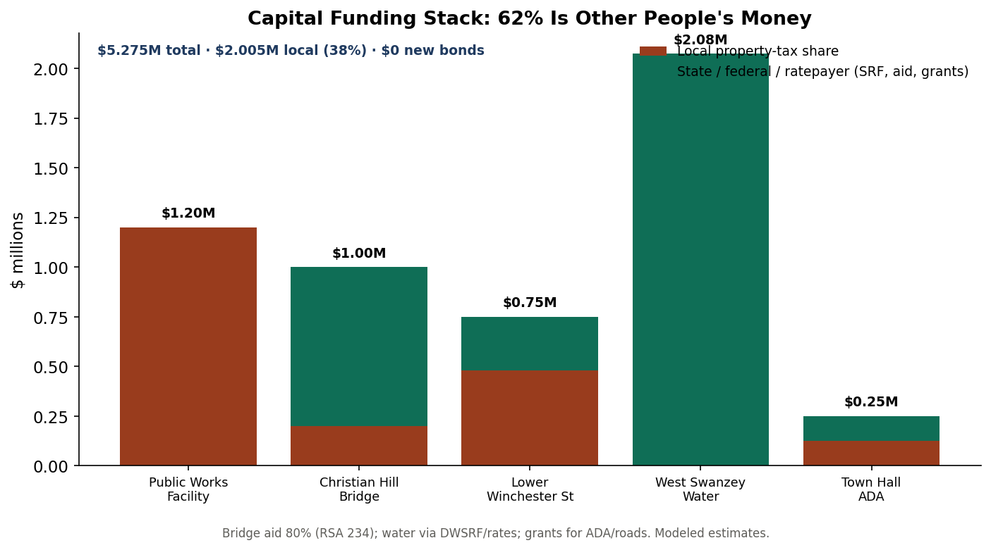
Of about $5.275M in capital needs, only ~$2.005M (38%) is local — raised through majority-vote reserves, with zero new bonds and zero 3/5 votes.
What it costs a $300,000 home
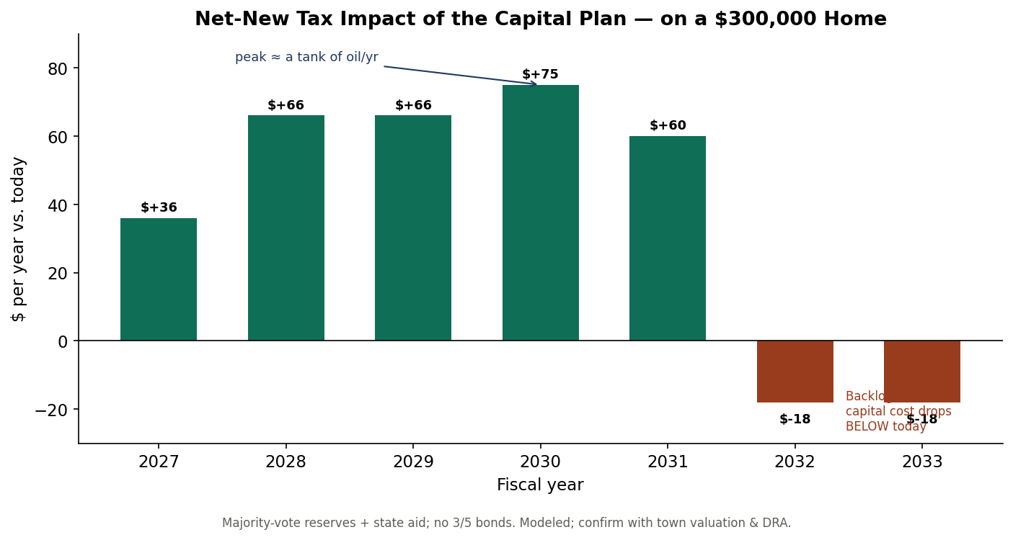
The hardest year adds about $75; by 2032 the backlog is cleared and the capital burden falls below where it is today.
This is already underway — the record validates it
In 2025 voters acquired the West Swanzey water system (RSA 38:4), created a West Swanzey TIF district, and funded a study explicitly expecting '100% principal forgiveness' from the DWSRF. The town has already started financing capital the way this plan recommends; the task is to extend that discipline to the facility, bridge, street, and ADA projects.
Recommendation
Adopt a six-year CIP built on majority-vote capital reserve funds; pursue 80% bridge aid and DWSRF water financing; build the public works facility pay-go by 2031 — no bond, no 3/5 vote. Model warrant articles accompany this report (Capital Warrant Articles.pdf).
Funding mechanics & statutory shares are real (RSA 234/35/38, NHDES DWSRF); project costs and the tax glide are planning estimates [M] — confirm with engineering, NHDOT/NHDES, and DRA.

